Relax Challenge Report

There are two datasets for this project. One contains information about the 12,000 users, while the other logs 207,917 instances of user engagement (user logins). Of the 12000 total users, there are 1656 adopted users.

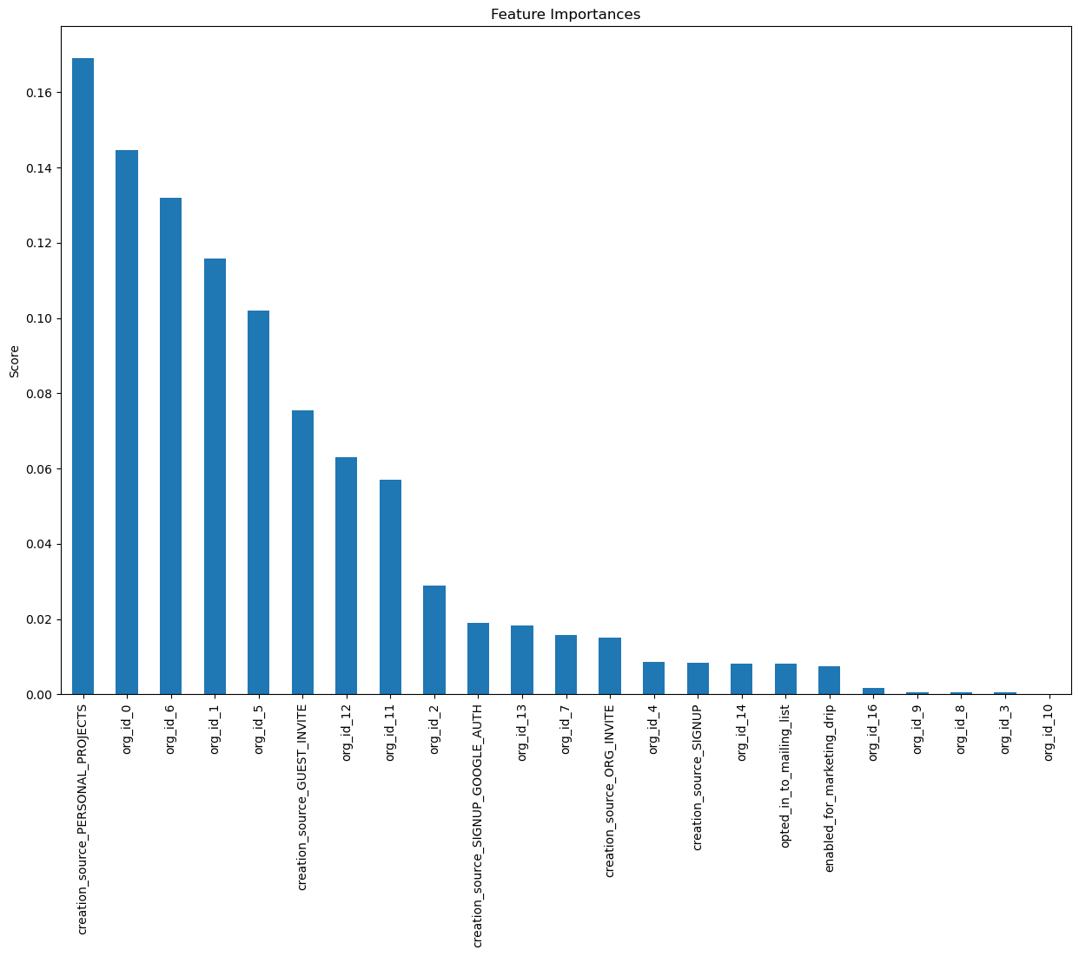

We found that creation_source_PERSONAL_PROJECTS is the most important predictor. By breaking them into clusters, we can see the large spectrum of feature importance placed on each groupingMarketing targeted at individuals with strong personal drive for own projects could be effective as well as incentives for bringing in colleagues .I built a gradient boosting classifier model on the preprocessed data and achieved about 88% accuracy rate.